Table 1: Data used for this report

|  |  |  |
| --- | --- | --- |
| SPY | Stock index | SP500 |
| HSI | **Stock index** | **HS (hang seng)** |
| TYX | **30 years treasury index** | **TYX** |
| COR | **10 years corporate bond index** | **Corporate** |
| REA | **Real estate index** | **DJ** |
| GOL | **Commodity index** | **Gold Price** |
| BTC | **Bitcion index** | **BTC** |

Cumulative Returns Comparation for all the index mentioned above

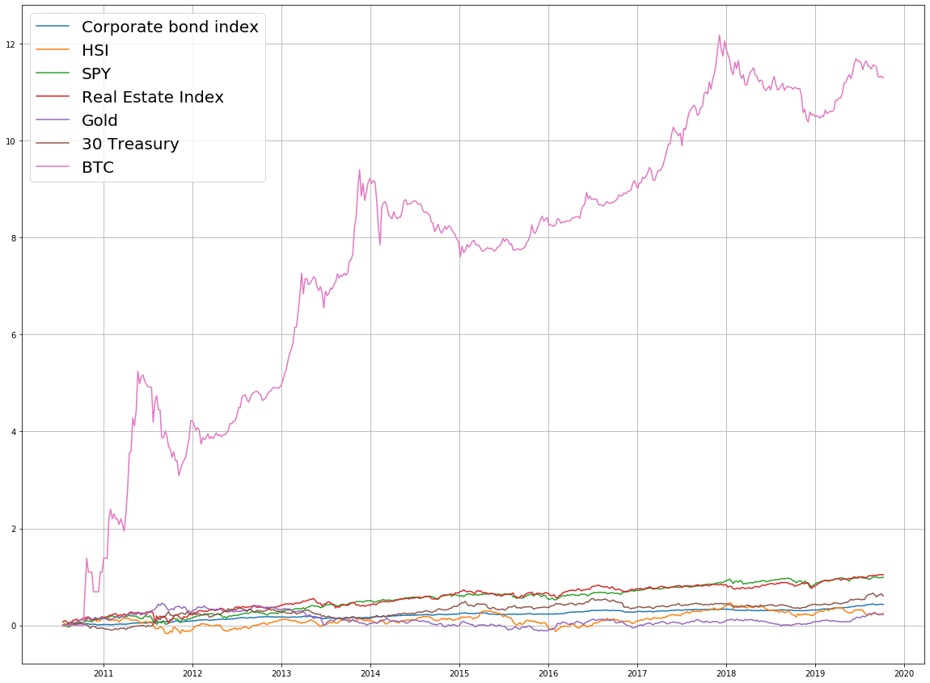

Figure 1 Cumulative Returns

Table 2: Correlation table of all the index

|  |  |  |  |  |  |  |  |
| --- | --- | --- | --- | --- | --- | --- | --- |
|  | HSI | COR | SPY | REA | GOL | TYX | BTC |
| HSI | 1.00 | 0.65 | 0.79 | 0.69 | -0.37 | 0.41 | 0.77 |
| COR | 0.65 | 1.00 | 0.95 | 0.98 | -0.41 | 0.92 | 0.69 |
| SPY | 0.79 | 0.95 | 1.00 | 0.97 | -0.52 | 0.78 | 0.77 |
| REA | 0.69 | 0.98 | 0.97 | 1.00 | -0.48 | 0.87 | 0.69 |
| GOL | -0.37 | -0.41 | -0.52 | -0.48 | 1.00 | -0.27 | -0.15 |
| TYX | 0.41 | 0.92 | 0.78 | 0.87 | -0.27 | 1.00 | 0.53 |
| BTC | 0.77 | 0.69 | 0.77 | 0.69 | -0.15 | 0.53 | 1.00 |



Figure 2: heatmap for correlation

Table 3: Optimal portfolio with BTC VS without BTC

|  |  |  |
| --- | --- | --- |
|  | **weights without BTC** | **weights with BTC** |
| **HSI** | 0% | 0% |
| **COR** | 76% | 76% |
| **SPY** | 16% | 14% |
| **REA** | 8% | 7% |
| **GOL** | 0% | 0% |
| **TYX** | 0% | 0% |
| **BTC** |  | 2% |
| **TOTAL** | 100% | 100% |

Figure 3: portfolio weight with BTC VS without BTC

Figure 4: Efficient Frontier with BTC VS without BTC